OFFICE USE ONLY Applicant ID: 2017SeptemberNicaragua Approval Date: 9/13/2017

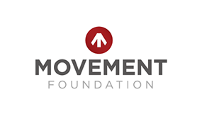
MOVEMENT FOUNDATION MISSIONS GRANT REQUEST

Missions Church/Organization: | AMOUNT OF REQUEST:
In His Steps Nicaragua  Lead by Brett Harbinson 9/13-9/17 | $ 5,900

Evie Barrantes
Nikkole Bigbee
Brett Harbinson (Team lead compensation $1,400)
Angela Impat
Jericho Kinyanjui
Patty (Yvonne) Quintero
Eric Tan
Brittany Wellborn
Michael Wellborn
Tatyanne Wilson

Prepared By: | Bethany Cord

